









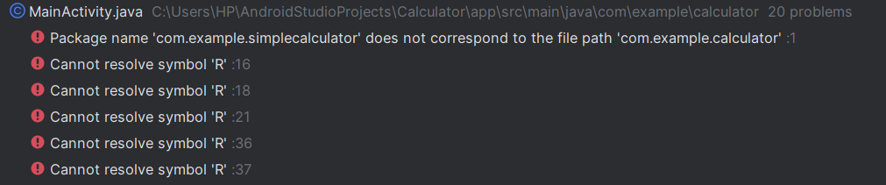

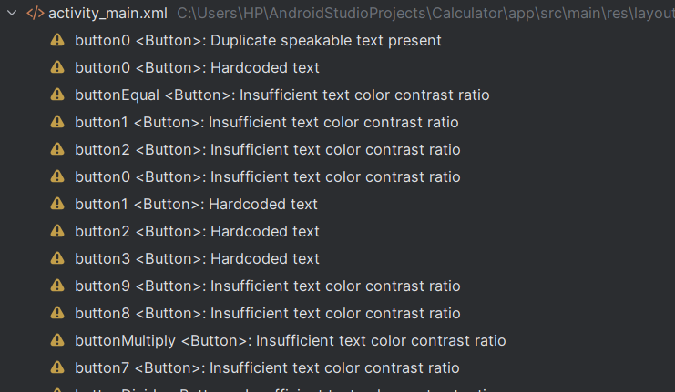



**Implementation Phase: Final Output(no error)**

**Create a New Project**

**Select "Empty Activity" and click Next.**

**Enter the project details:**

* + **Name: Calculator**
  + **Language: Java**

**Modify Styles.xml**

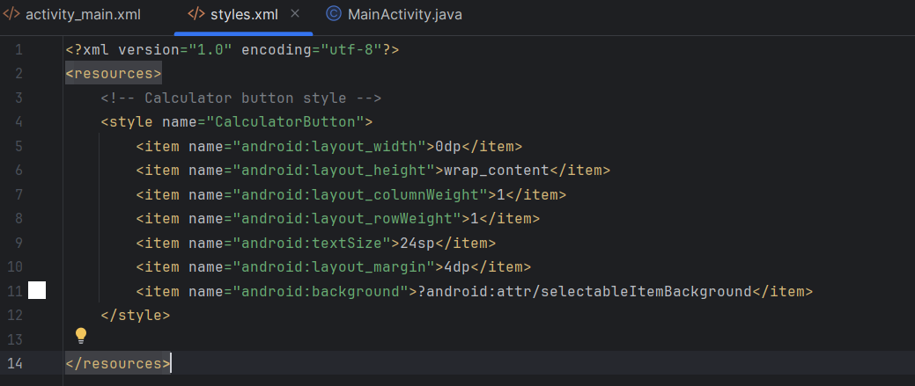

**Implementation Phase: Final Output(no error)**

**Step-2: Modify the Layout (activity_main.xml)**

1. **Open res/layout/activity_main.xml**

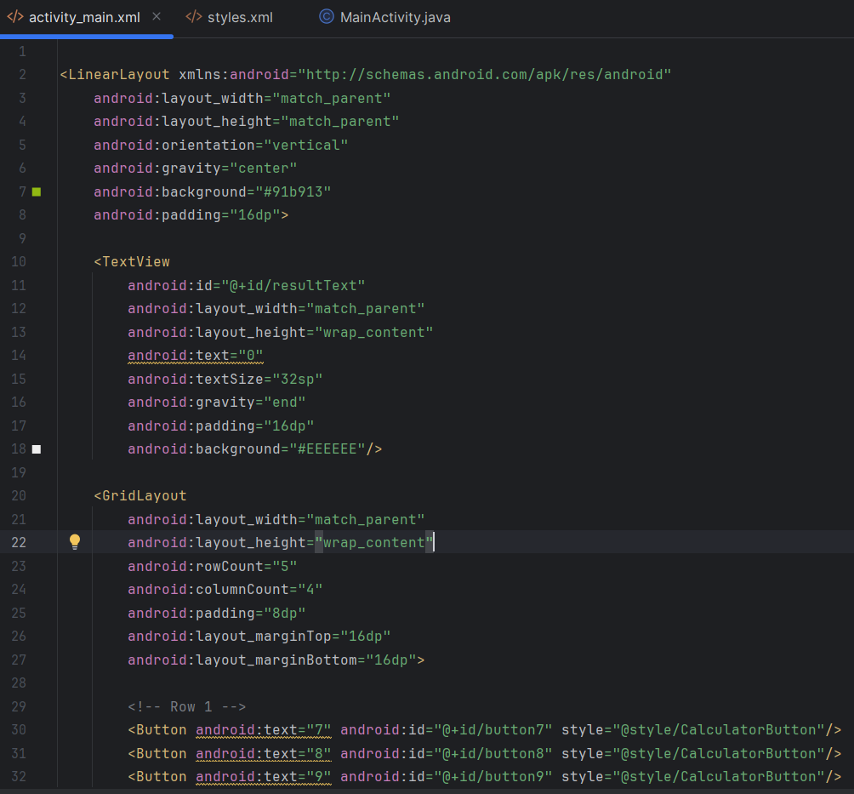

**Use EditText for input fields, TextView for displaying results, and Button for operations (+, -, ×, ÷).**

**Set unique id attributes for EditText, Button, and TextView elements in activity_main.xml.**

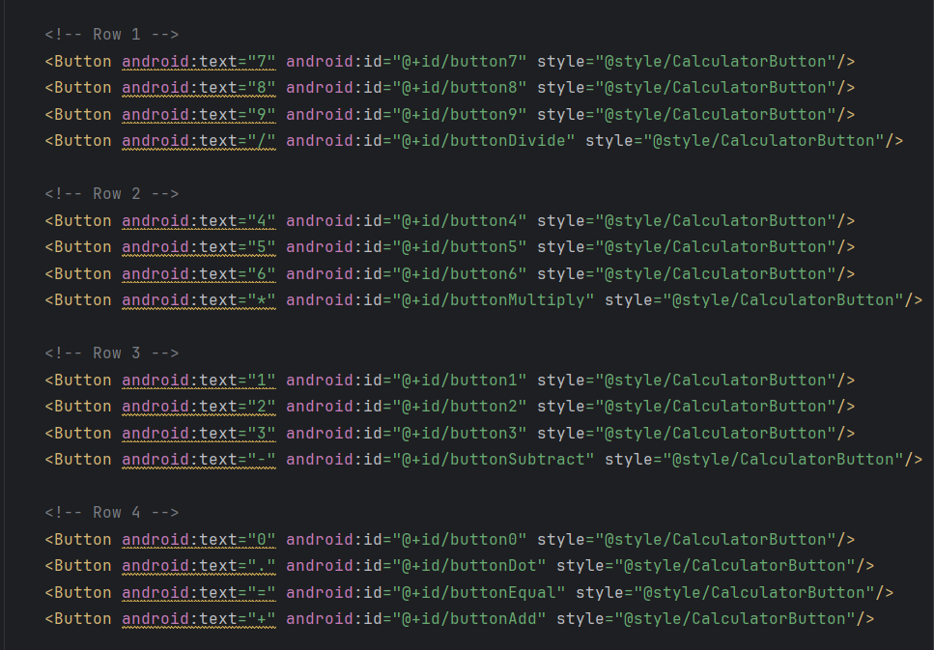



**Implementation Phase: Final Output(no error)**

**Step 3: Modify MainActivity.java**

**In MainActivity.java use findViewById() to link UI elements. Set OnClickListener for each button to perform the respective arithmetic operation.**

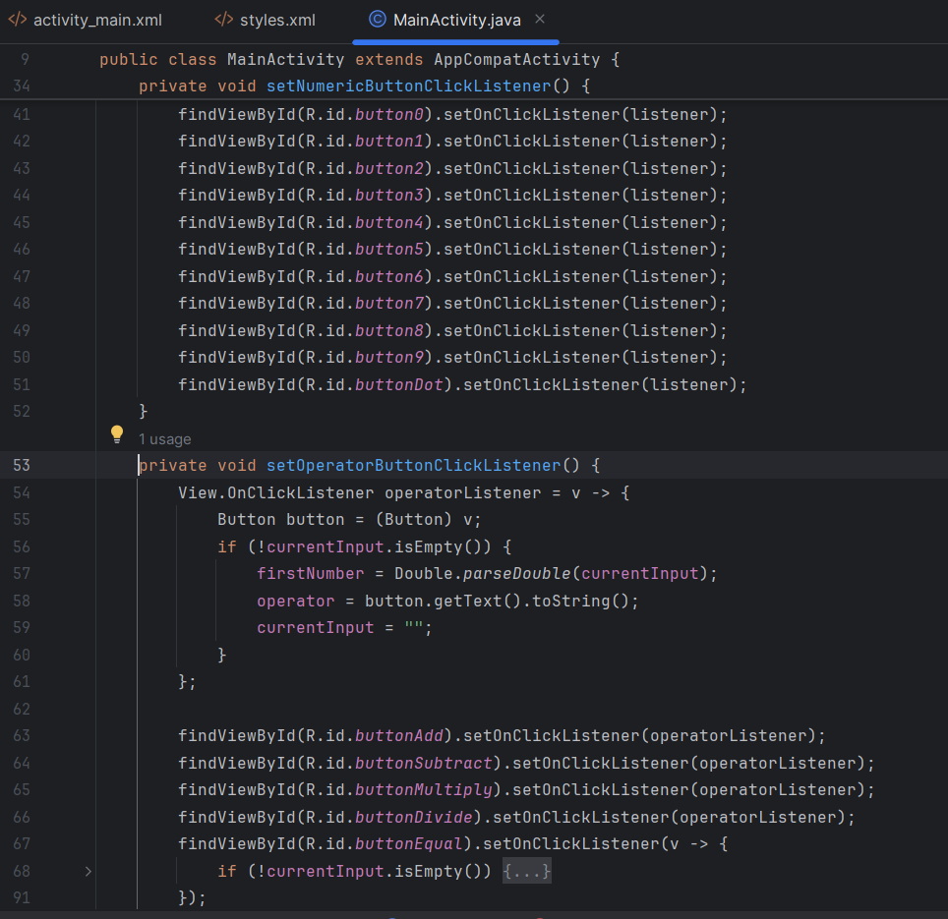

**Switch to design view to see the UI Design**

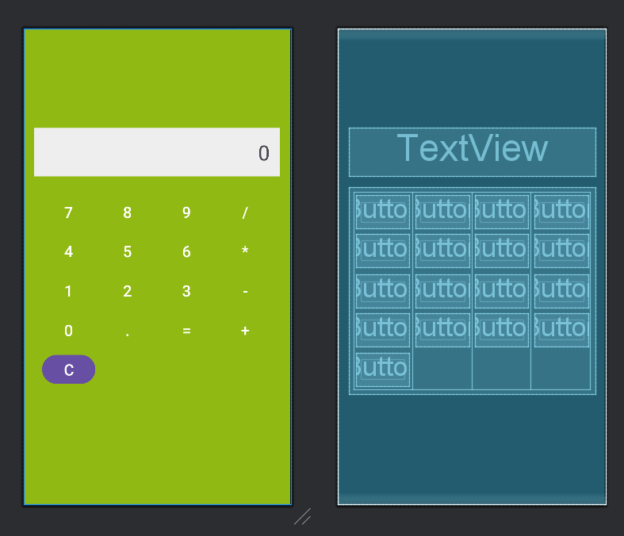



1. **Click Run**
2. **Select an emulator or a connected Android device.**





        
        
        
        
        
        
        
        
        

